- Our new home buyer affordability index indicates that whereas house prices were 33% overvalued in Q4 2022, the valuation gap has receded to only 4% now. This means the recent pickups in UK mortgage activity and house prices is likely due to a substantial improvement in housing affordability over the past three years.
- However, we think the big improvements in affordability are now behind us. Pay growth is slowing, and financial market pricing already anticipates further rate cuts, suggesting limited room for swap rates and mortgage rates to fall from their current levels.
- With supply still tight, we forecast a steady increase in house price inflation over the next few years. However, with further affordability gains expected to be modest, mortgage activity is likely to plateau from early 2026 at levels similar to those seen before the pandemic.
The UK housing market has been subdued for the past three years, with prices falling in real terms and lending activity mostly below pre-pandemic norms. Affordability constraints were the main factor behind the sluggish post-pandemic performance, with most metrics showing housing was significantly overvalued compared with the average since 2000.
However, as distortions caused by the March change in stamp duty thresholds have faded, lending activity is running at much higher levels than a year ago. Similarly, the lenders' indices have reported firmer house price growth in recent months. We attribute these improvements to stronger demand supported by a big improvement across all the affordability metrics that we track (Chart 1).
Indeed, for two metrics, house prices now look undervalued compared with historical averages. Lenders have been willing to advance larger loans compared to property values in recent quarters, improving accessibility of finance. Meanwhile, a sustained period of very strong growth in rents means that buying a house looks more appealing compared with renting.
Chart 1: Affordability has improved significantly over the past three years
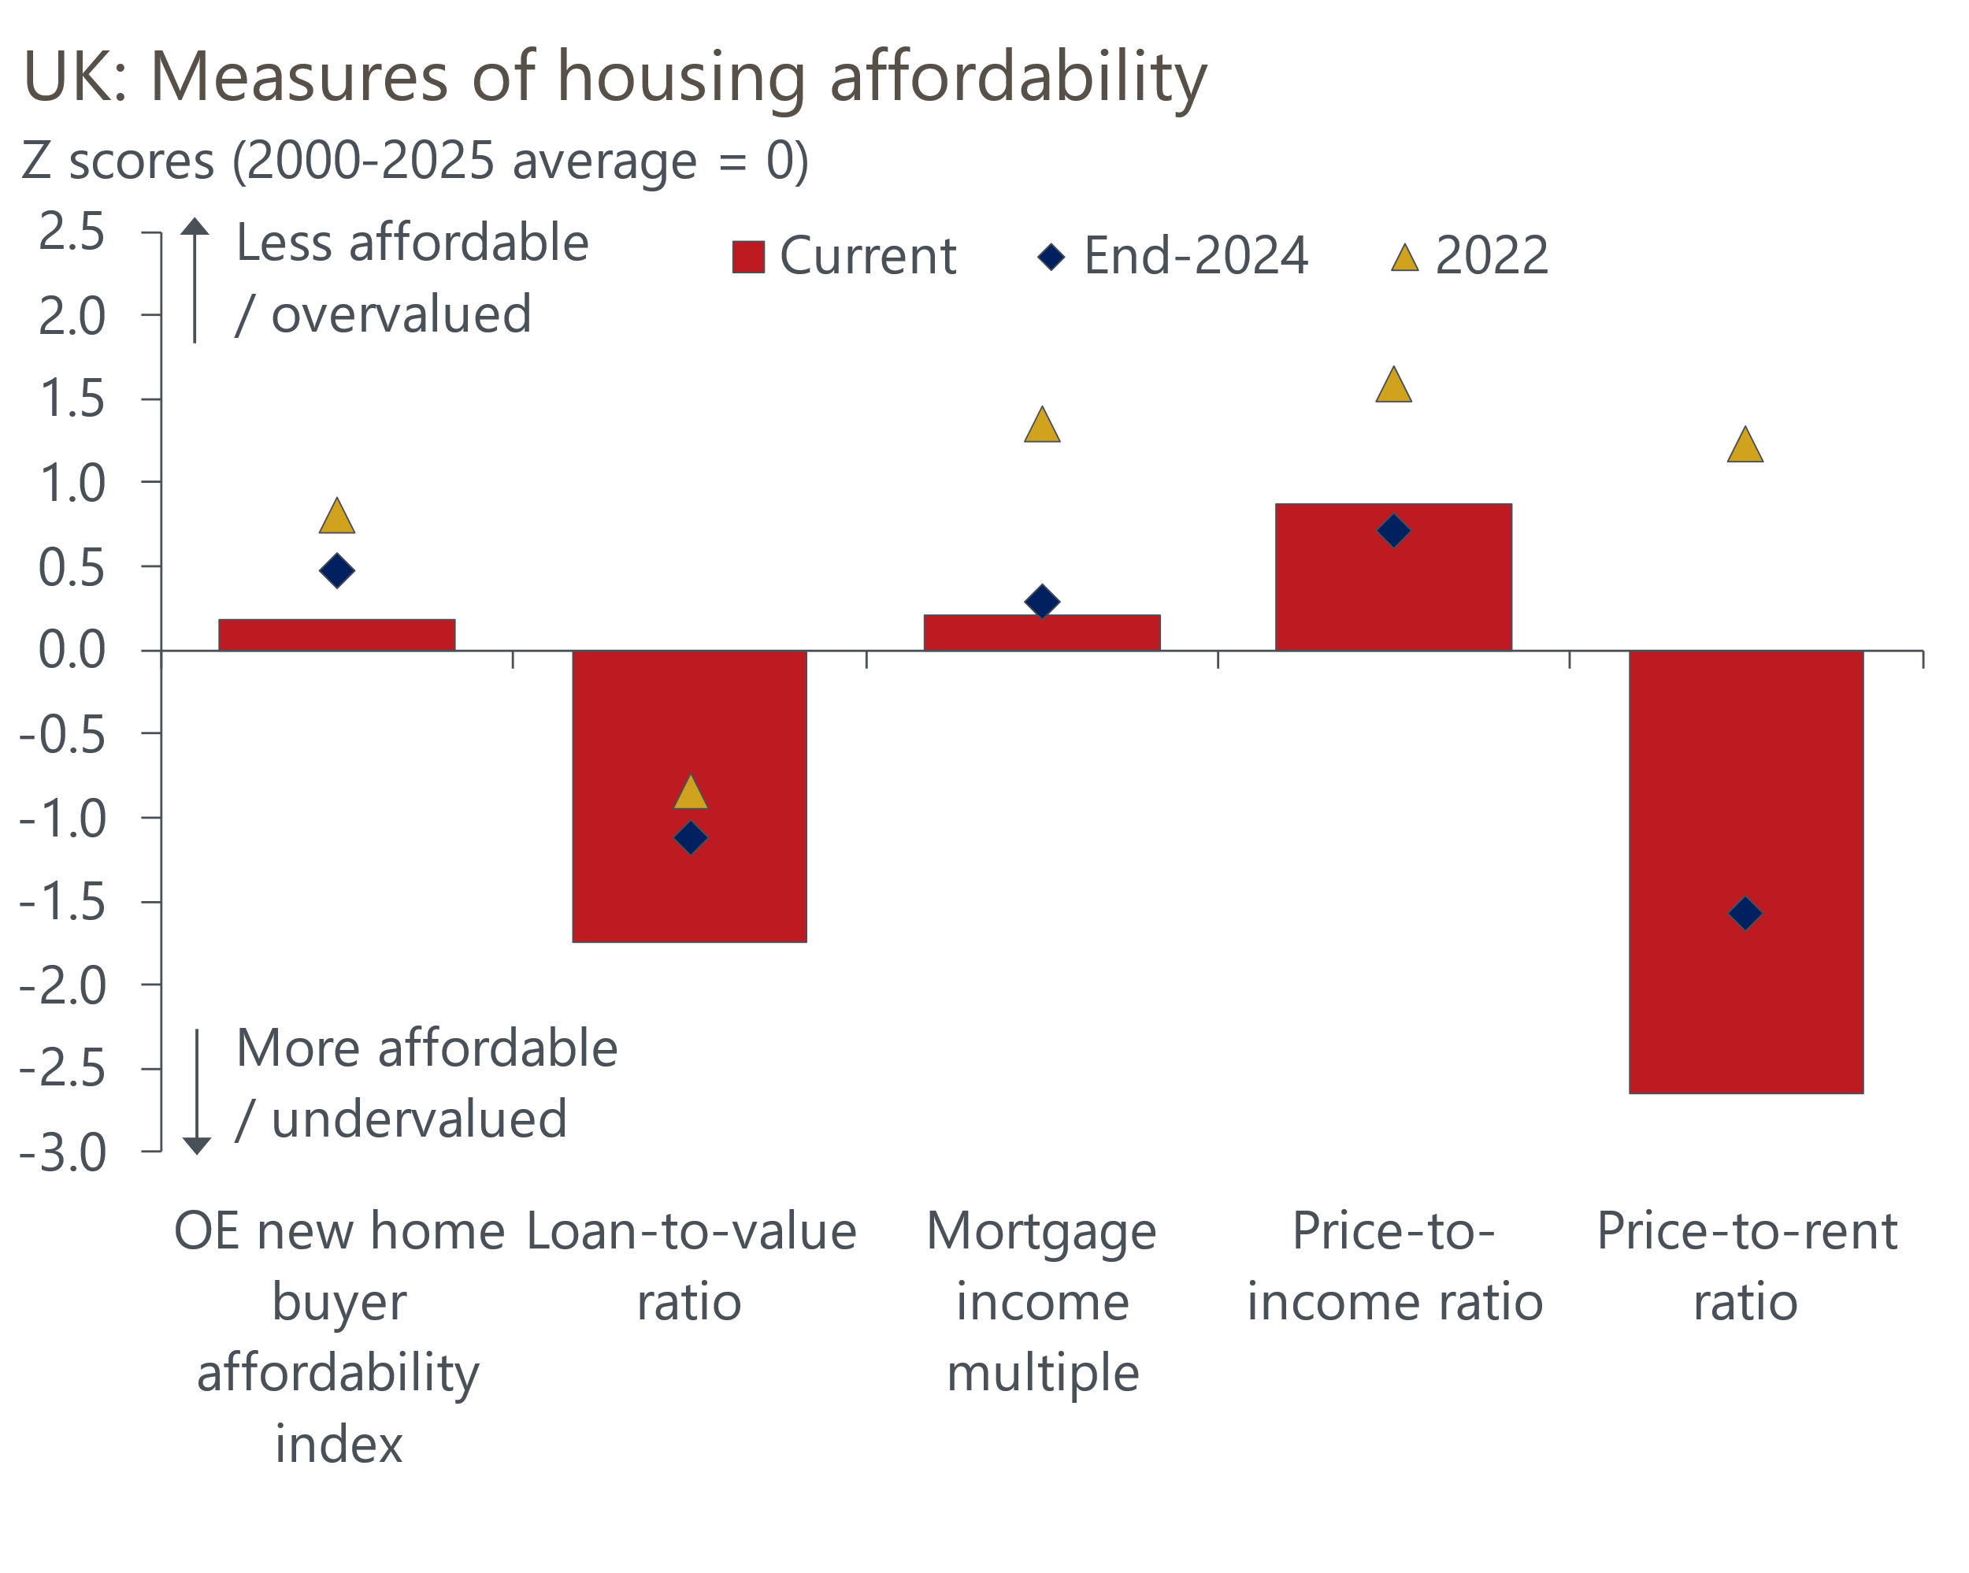
Source: Oxford Economics calculations using data from Haver Analytics

While other metrics remain somewhat stretched compared with historical norms, conditions have improved significantly since 2022. Sustained strong pay growth has been a key driver of this improvement, and in combination with a steady decline in mortgage interest rates, this has underscored a substantial improvement in the affordability of mortgage payments.
Our new home buyer affordability index is based on mortgage repayment costs for the average property with two- and five-year fixed-rate mortgages. In Q4 2022, following a spike in mortgage rates triggered by the Truss government's mini-Budget, our indicator indicated a 33% overvaluation in prices. Subsequently, there has been consistent improvement, with our index now showing house prices as only 4% overvalued compared to the 2000-2020 average (Chart 2).
Chart 2: The affordability of mortgage payments has improved substantially since late-2022
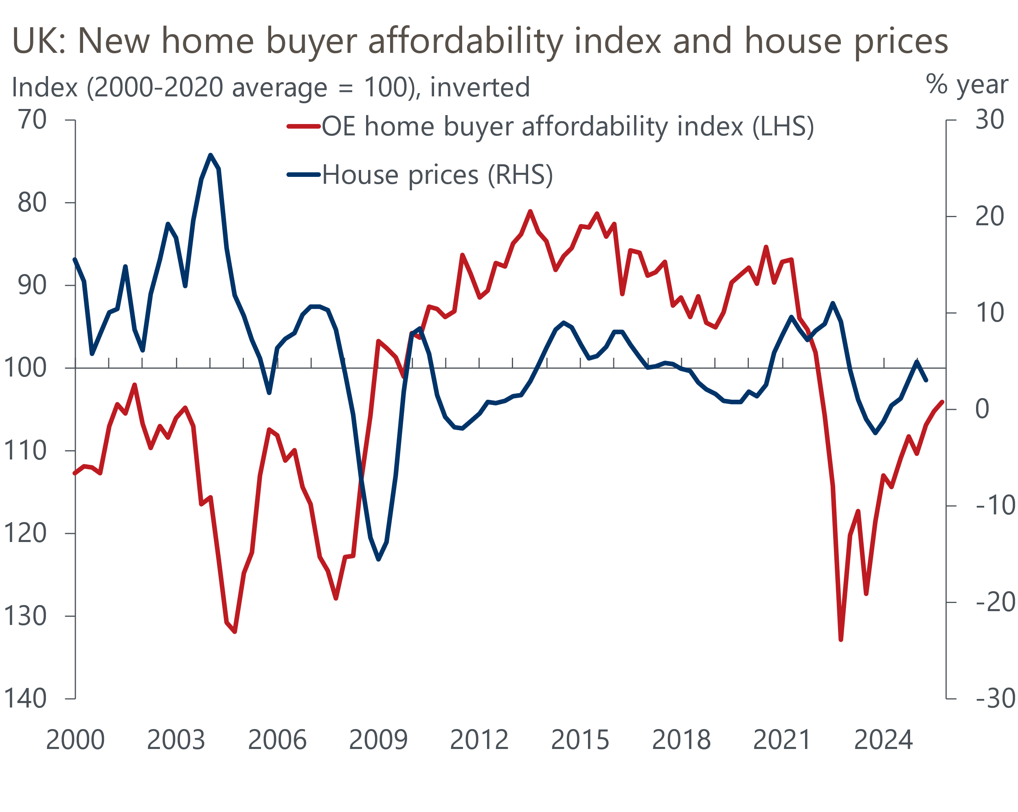
Sources: Oxford Economics, Haver Analytics

We expect further improvements in mortgage affordability will be modest
A receding valuation gap indicates a solid foundation for the recent upturn in activity and prices. However, we don't believe this marks the beginning of a new housing boom. That's mainly because we consider the bulk of the improvement in mortgage affordability to be in the past. Pay growth slowed in 2025 and is projected to cool further next year. In addition, we anticipate only a slight drop in fixed-term mortgage rates (Chart 3).
Chart 3: We expect mortgage rates to fall modestly over the coming year
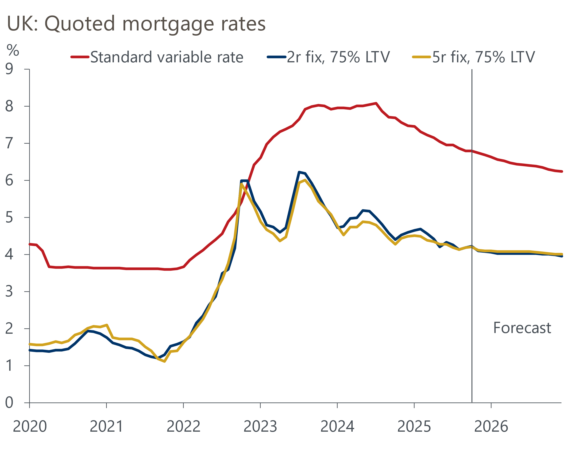
Sources: Oxford Economics, Haver Analytics
The downside surprise on inflation in September and dovish signals from the Monetary Policy Committee's November meeting prompted markets to re-price, with two- and five-year swap rates currently around 15bps below early-October levels. This is expected to lead to lower mortgage rates in the coming weeks.
Market pricing suggests Bank Rate will reach the 3.25%-3.5% range by the end of next year, aligning with our forecast. Although the terminal rate may ultimately prove to be slightly lower, future drops in swap rates are expected to be less pronounced than in recent years. Consequently, we anticipate that average two- and five-year fixed-rate deals for 75% loan-to-value mortgages are unlikely to drop much below 4%.

Refinancing hump hasn't forced large numbers of sales
Mortgage demand has strengthened, but the supply of houses for sale remains low. Approximately 90% of mortgages are on fixed interest rates, leaving most mortgagors facing significant rate hikes over the past three years, as previous cheap fixed-rate deals expired, and borrowers were forced to refinance at substantially higher rates. While this has caused a slight uptick in arrears, the number of borrowers failing to meet mortgage payments remains significantly lower than post-global financial crisis levels (Chart 4).
Chart 4: Financial stress has remained relatively low, despite much higher mortgage rates
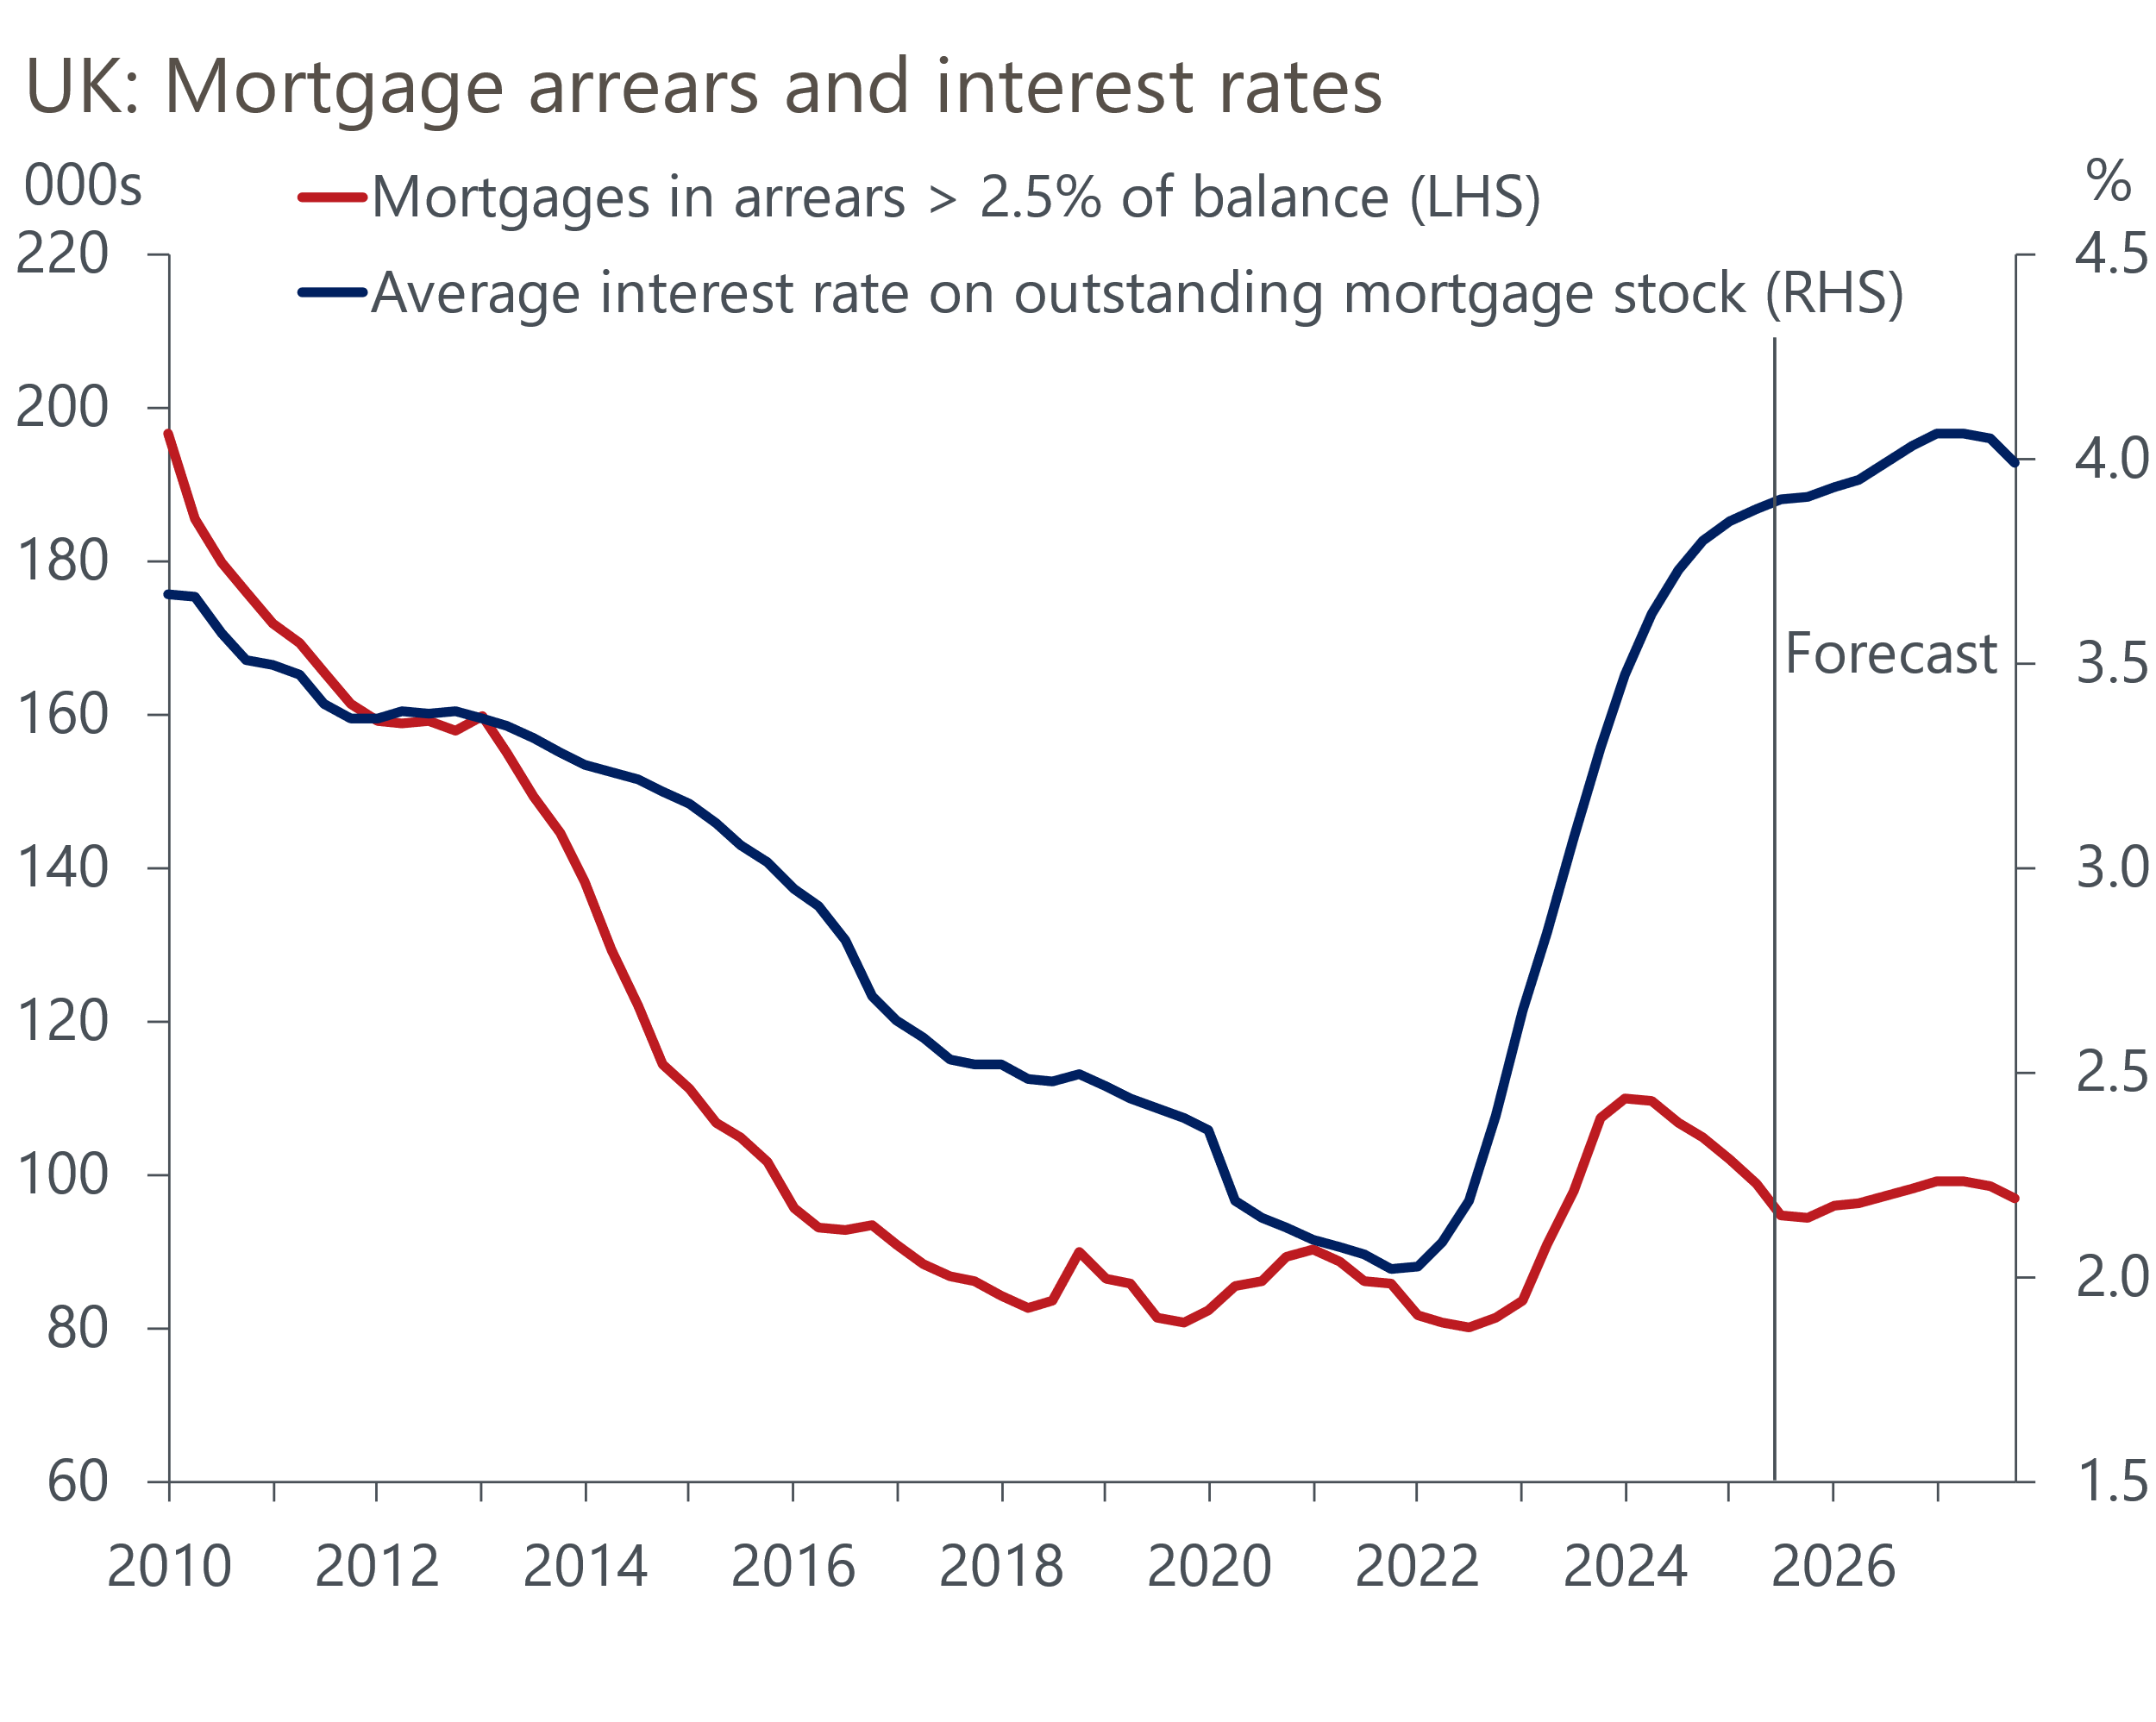
Sources: Oxford Economics, Haver Analytics
Households' resilience to a significant rise in borrowing costs likely stems from low unemployment. Although we anticipate a slight increase in joblessness and a still-substantial minority of borrowers need to refinance at much higher mortgage rates, we believe mortgage arrears have already peaked.
However, while the number of borrowers forced to sell their properties has been limited, the large increase in mortgage costs has also made it less viable for homeowners to trade up. Both factors have contributed to the low level of supply coming to the market, and a collapse in new house building has added to the downward pressure on supply. We struggle to see any reason why this situation will improve in the future.

Recovery in activity will peter out but there's scope for firmer price growth
We expect the combination of low supply and firm demand to support house price growth over the next few years. Our forecast shows house price inflation accelerating from 2.4% in Q4 2025 to 3.4% by the end of next year and 3.6% in Q4 2027 (Chart 5). Our new home affordability index suggests prices will stay slightly above fair value, similar to current valuations.
Chart 5: House price growth should strengthen, even as lending activity plateaus
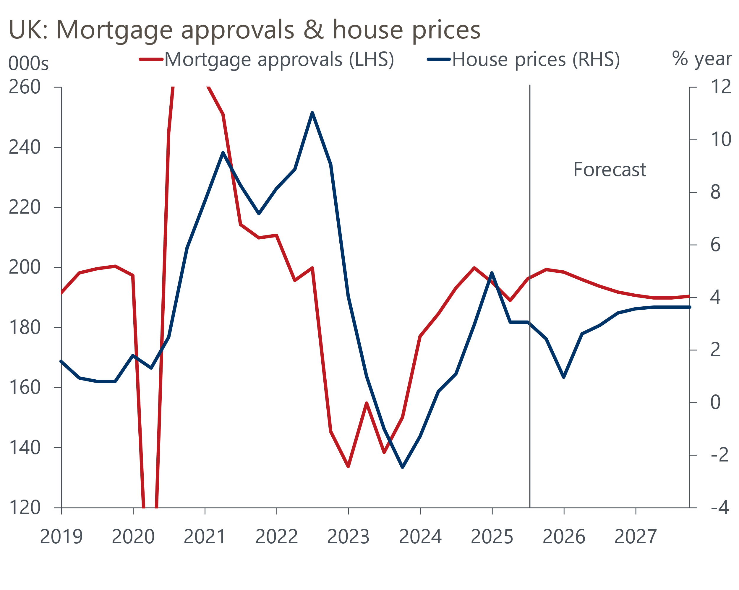
Sources: Oxford Economics, Haver Analytics
The recent increase in mortgage activity is likely to continue over the rest of this year as rates edge down further. However, as affordability improvements peter out, we project lending activity will plateau and then decline. So mortgage approvals and lending volumes should stabilise near pre-pandemic levels, but well above the 2023-2024 figures.

The Budget is unlikely to affect the mainstream market substantially
The upcoming Budget on November 26 poses significant uncertainty for the UK economy. Media speculation has covered several potential measures affecting the housing market, such as expanding council tax bands and imposing capital gains tax on primary residences. Primarily, these would impact the high-end of the market, with minimal direct effects on the rest in the short term. For instance, it's improbable that numerous homeowners would need to sell due to increased council tax rates. However, this change might slightly reduce attractiveness in certain areas in the medium term.
A more important risk factor than direct policy measures is the impact that the Budget might have on financial market pricing. As we set out in a recent note, if markets aren't convinced by the Budget and sterling sells off, this would exacerbate the UK's inflation problems and could prevent the Monetary Policy Committee from cutting Bank Rate further. In this scenario, swap rates would be higher and quoted mortgage rates could edge back towards 4.5% next year. With growth in household incomes weaker, this would weigh on mortgage demand and prices.

